File : 2.3_varyC1p10p_W60uL600n_2.5V_30uto45u_conservative.xls

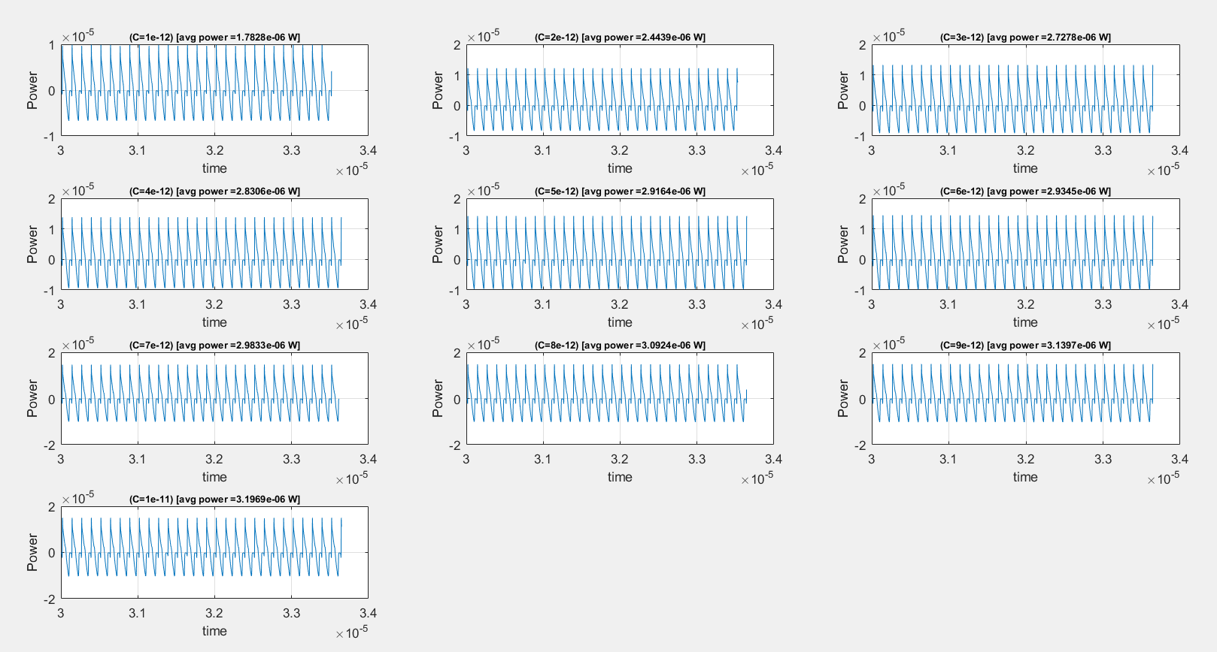



Vripple for all the caps

